Standup against Street Harassment

A session on safety on roads was conducted for students online by Shoolini University in collaboration with NGO “Breakthrough” and “Mudita Foundation”. The NGO representative Mr. Sanjay shared his own story of being bullied and harassed. This was the reason why he decided to join Mudita Foundation and become a spokesperson. He identified various kinds of harassment that take place. He guided students how to be more aware of their environment and be ready to accept and face unwanted situations. The session was highly interactive with polls and quizzes. All in all, a highly informative and engaging session that have a picture of the reality of the outside world.

Number of students participated: -142
Poster made for the talk
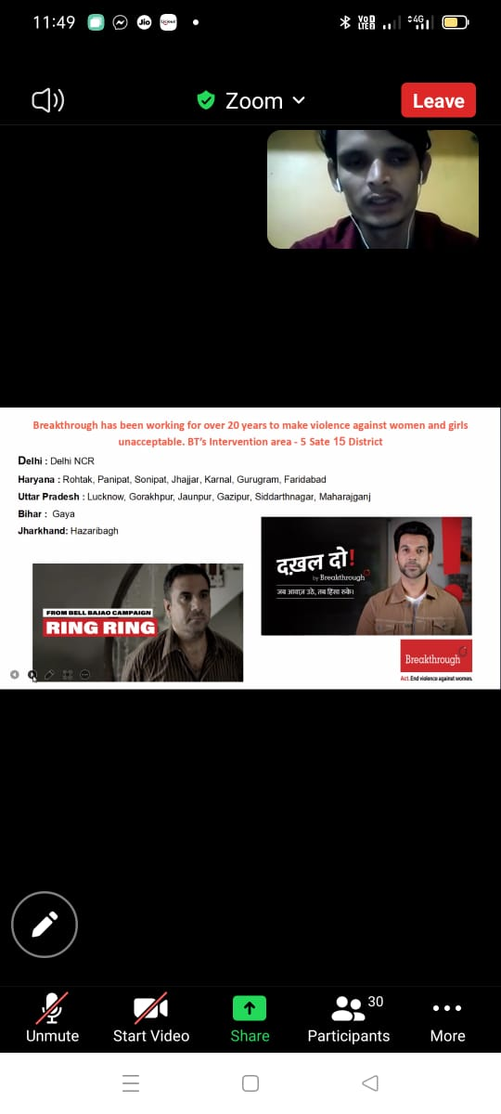
Mr. Sanjay sharing his life story
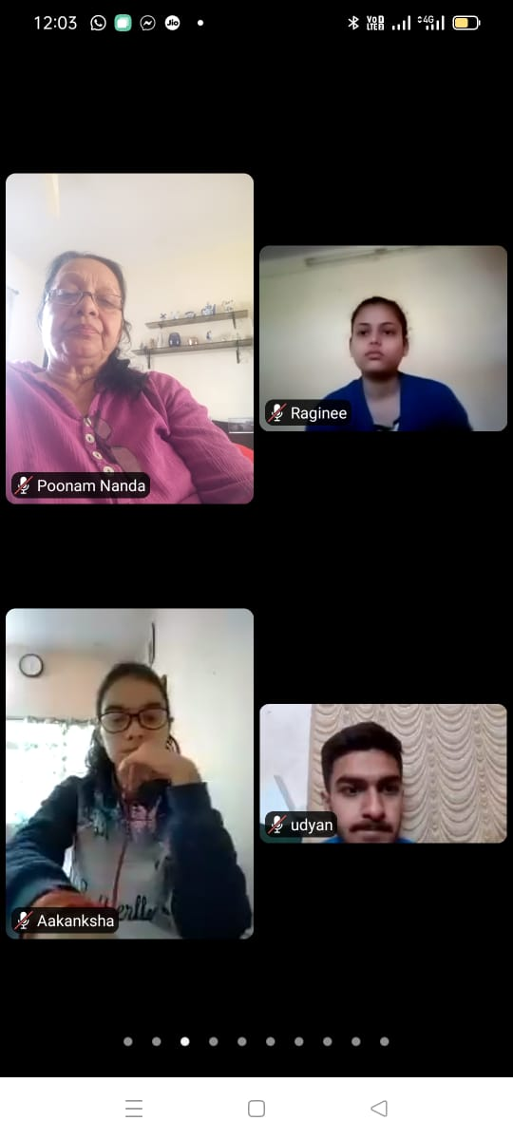
DSW Mrs. Poonam Nanda and students attending the session

