October 10, 2021

World Mental Health Day

Shoolini University organized a Webinar to celebrate Word Mental Health Day on October 10. The speaker of the event was Mrs. Sonal Gupta, Educator and Student Counselor. Dean or Student welfare, Mrs. Poonam Nanda began the event by talking about the mental health issue and its impact on youth during the pandemic. She said that mental health is even more important than physical health in the time we are in. Further, Mrs. Nitika Thakur, Assistant Professor shared a poetry based on shades of love and psychology.
Sonal Gupta began the talk with gender expression and the judgement trans people face in the society. She illustrated the gender biasness and explained them with different rhetorical questions. She further explained that LGBTQ community are just asking for the basic and fundamental human rights, nothing more. This talk was attended by more than 140 students.

Number of students participated: - 140

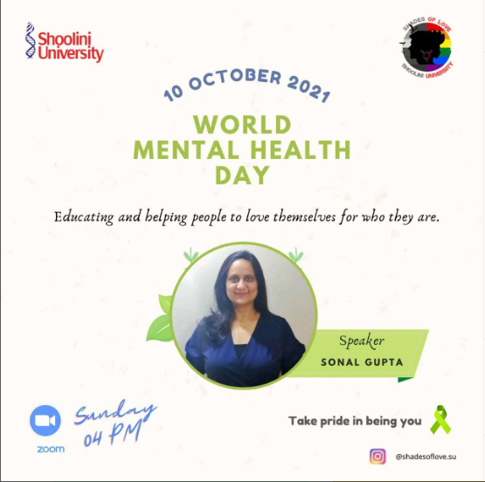
Poster created for the event

